Jane & John

Bed and Breakfast

Software Test Specification

27 September 2015

Michael Straughan

Brent Srnka

Kimmo Takala

CMIS 330 6381

Software Engineering Principles and Techniques

Ronald McFarland

**1. Introduction**

**1.1 Objectives**

The objective of this document is to outline test procedures for verification and validation of the software for the Jane & John Bed and Breakfast (JJBB) reservation system. All modules and their interfaces will be tested in order to reduce or eliminate any errors caused by the software and to ensure that all exceptions are handled in a manner that makes the system stable and user friendly. This Software Test Specification (STS) document well contribute to these objectives.

**1.2 Background**

Jane and John want a software system developed that will allow them to create reservations and track cost and profit for their Bed and Breakfast. The system must be cost effective, functional and of good quality, and must be delivered in a timely manner. The system must be able to handle credit card transactions, store financial and reservation data, and recall this data.

**1.3 Scope**

The scope of this STS document covers the testing of the software for the system that will be used with the hardware included for the system. It does not cover any elements outside the system such as online transactions. This is the first iteration of this STS document, therefore it is subject to change in future iterations.

**1.4 References**

This standard shall be used in conjunction with the following publications:

IEEE Std. 829-1998, IEEE Standard for Software Test Documentation

IEEE Std. 1016-1998, IEEE Recommended Practice for Software Design Descriptions

IEEE Std. 830-1998, IEEE Recommended Practice for Software Requirements Specifications

JJBB-SDD-A01-092715 Software Design Document for Jane & Joe’s Bed & Breakfast.

JJBB-SRS-A01-091715 Software Requirement Specification for Jane and Joe’s Bed & Breakfast.

**1.5 Test Environment**

The test environment for the system will be onsite at the Jane & Joe’s Bed and Breakfast. The system will be used indoors with access to commercial power and network capabilities.

**1.5.1 Hardware**

The computer hardware and peripherals used for the reservation system will be a commercial off the shelf (COTS) computer. It will be Ethernet capable and run on commercial power. The processor will consist of at least a 3.4 GHz Core i7 processor. A minimum of 8GB of DDR3 RAM will suffice for memory for the actions that must be performed by the system. The computer will have a minimum 1TB internal hybrid drive. A universal serial bus keyboard and mouse will be used for navigation and data input. A 19 inch display monitor with Digital Video Interface will be connected to the computer to display output to the user. The system will use an 8-bay network attached storage device that will be used to store data for the database. This will allow for RAID configuration and storage upgradeability. The external Credit card machine will be connected to one of the USB ports.

**1.5.2 Software**

The JJBB reservation application is data centric meaning that the application is built around the data. The application is designed using the Microsoft Access 2013 database Integrated Development environment. The customer is running Windows 7 ultimate (64-bit) Operating System. With all updates and patches installed. Microsoft Office 2013 Professional Edition is installed on the customers machine. The customer has the latest Norton Internet Security version:21.7.0.11. In addition the Credit Card machine comes with its own software and drivers to facilitate recording of all transaction records into local tables on the hard drive.

**1.5.3 Test Tools**

The application Shall be tested using the same hardware configuration and Software operating system as that of the customer for which the application is being built. Much of the testing is limited to the UI which comprises the bulk of the main testing black box testing.

Additional Tools used in testing this application include but are not limited to features of the IDE provided by the Microsoft Office 2013. These features include intellesense, immediate window, locals window, watch window, and debug statements placed in various location throughout the source code to facilitate testing of the error handler capabilities and to document and monitor input and output data to test and observe and document instances of objects, variables and properties at run time.

**1.5.4 Data**

A model database housing fictitious data is used to facilitate adequate testing of all the application features stipulated in the SRS, SDD, and this STS. A full battery of test data is included and loaded into the database for the purpose of conducting testing of the functionality of the application. All the data supports testing and documenting.

**2. Architectural Context Diagram**

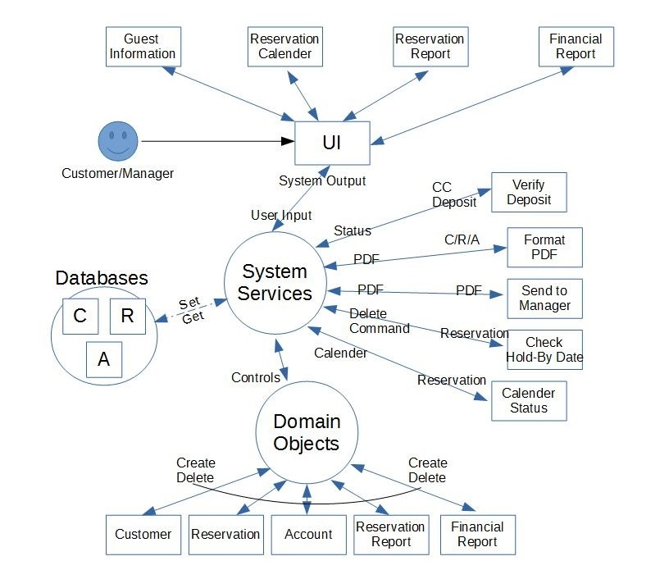

**2.1 User Interface**

A screenshot of the Main Graphical User Interface follows:

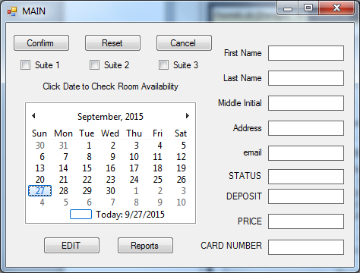

The following flow diagram and listed sequence of event depicts how the User Interface will be used when a customer calls to reserve a suite.

1. 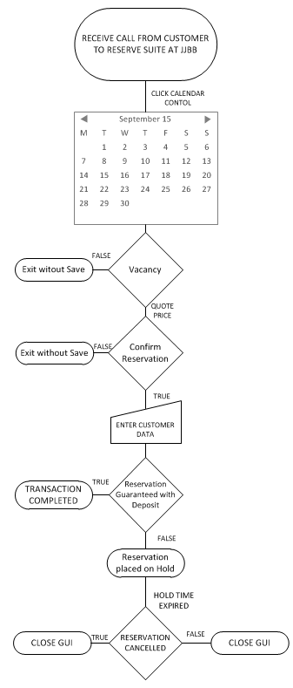receive call from customer requesting to reserve a room.
2. User enters name of customer.
3. If customer has reservation, data is automatically populated from database
4. Data in Main GUI is not editable if customer in DB
5. Data is editable when User clicks EDIT
6. If customer not in DB, User clicks calendar control for date in question.
7. Price automatically display from price schedule based on season
8. Status automatically display Reserved, Hold, Cancelled
9. Deposit automatically display amount of deposit
10. Suite Check Box are greyed out if room reserved, otherwise selectable.
11. If customer agrees on price Enter customer information
12. Conduct deposit transaction
13. If Transaction complete click Confirm button
14. If no deposit negotiate limited hold time for reservation confirmation
15. If hold time expires cancel reservation
16. User clicks Reports to view or print various reports

**2.2 System Services**

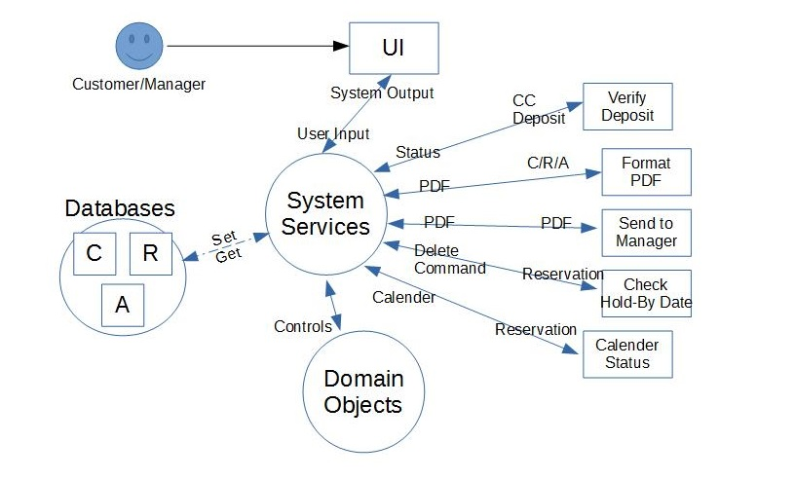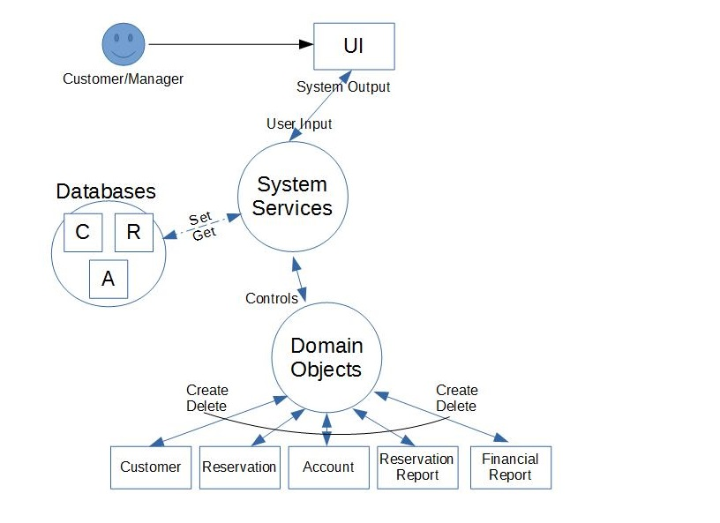**2.3 Domain Objects**

**3. Traceability Matrix**

|  |  |  |  |  |  |
| --- | --- | --- | --- | --- | --- |
| **Test Case ID** | **Category** | **Sub Category** | **Use Case** | **System Req.** | **Pass/Fail** |
| JJBB-01a | UI | Reservation Calendar | Case 1 | 1 | Pass |
| JJBB-01b | UI | Reservation Calendar | Case 1 | 2 | Pass |
| JJBB-02a | UI | Guest Information - Valid | Case 1, Scenario 3,4 | 3, 4 | Pass |
| JJBB-02b | UI | Guest Information - Invalid | Case 1, Scenario 1,2 | 3, 4 | Pass |
| JJBB-03 | UI | Reports | Case 2, Scenario 1 | 6 | Pass |
| JJBB-04 | System | Verify Deposit | Case 1, Scenario 4 | 4 | Pass |
| JJBB-05 | System | Format PDF | Case 2, Scenario 1 | 6 | Pass |
| JJBB-06 | System | Send to Manager | Case 2, Scenario 1 | 6 | Pass |
| JJBB-07 | System | Check Hold-By-Date | Case 1, Scenario 3 | 5 | Pass |
| JJBB-08 | System | Calendar Status | Case 1 | 1 | Pass |
| JJBB-09 | Domain | Customer Creation | Case 1, Scenario 2,3,4 | 3 | Pass |
| JJBB-10 | Domain | Reservation Creation | Case 1, Scenario 2,3,4 | 2 | Pass |
| JJBB-11 | Domain | Account Creation | Case 1, Scenario 2,3,4 | 3, 4 | Pass |
| JJBB-12 | Domain | Reservation Report | Case 2 | 6 | Pass |
| JJBB-13 | Domain | Financial Report | Case 2 | 6 | Pass |

**4. System Specifications**

# 1. User will check calendar for reservation availability on date(s)

# 2. Select Dates and Rooms for Reservation

# 3. Enter Customer, Contact and Credit Card Information

# 4. Determine Deposit Status

# 5. Check Reservation Hold-By Dates. If overdue, Drop Reservation

# 6. Monitor Expenses and Profits

**5. Use Cases and User Scenarios**

**Use Case 1: Make New Customer Reservation**

A customer selects their reservation date(s), enters their customer details, contact information and credit card information and makes their deposit selection into the JJBB system. Once the customer has entered all of their required information they will submit their request and await confirmation.

**Precondition**: The JJBB system needs to be configured properly and have access to its Customer, Reservation and Accounting Databases. The system needs to be ready to accept a reservation request.

**Post**-**Condition**:

1. The system makes a reservation and responds to the customer with a confirmation.
2. The system does not make a reservation and requests the customer take corrective action. No reservation due to:
   1. Incorrect customer details/contact details/credit card information.
   2. Credit Card deposit does not go through

**Actor Profile**: A customer who desires to make a reservation for a date or range of dates. The customer can be new to the system or a returning customer.

**Sequence of Events**:

1. Customer selects date or range of dates
2. Customer enters customer information, contact information, credit card information
3. Customer submits a reservation requested
4. JJBB system checks for invalid user input
5. If conflict:
   * JJBB system prompts user to resubmit request with correct information
6. JJBB system checks credit card deposit information
7. If conflict:
   * JJBB system prompts user to resubmit request with correct information
8. The system adds customer to Customer Database, reservation to Reservation Database, account to Account database.
9. The system responds to customer with a successful reservation.

**Use Case 2: Request Report**

The management requests either a Reservation Report or a Financial Report from the JJBB system. Once a request is submitted, the system will output the queried report.

**Precondition**: The JJBB system needs to be configured properly and have access to its Customer, Reservation and Accounting Databases. The system needs to be ready to accept a reservation request.

**Post-Condition**: The system prints the requested report for the management.

**Actor Profile**: Management personnel who desires to review a JJBB reservation or financial report. The personnel is already setup to use the system.

**Sequence of Events**:

1. Management submits a request for a Report
2. JJBB system queries from the databases the required information and processes it into report formalize
3. The requested report is delivered to the management.

**User Scenario 1 for Case 1: Customer Requests Reservation with Invalid User Input**

1. Customer enters invalid information (either customer, contact or credit card information).
2. User submits the reservation requested.
3. JJBB system prompts the user to correct the invalid data entries and resubmit the request.

**User Scenario 2 for Case 1: Customer Requests Reservation with Deposit Failure**

1. Customer enters all required information correctly.
2. User submits the reservation request.
3. JJBB system prompts the user saying that the deposit has failed and to resubmit the request after corrections have been made.

**User Scenario 3 for Case 1: Customer Requests Reservation without Deposit**

1. Customer enters all required information correctly.
2. User submits the reservation request.
3. JJBB system prompts the user that the reservation has been made without guarantee to hold the rooms.

**User Scenario 4 for Case 1: Customer Requests Reservation with Successful Deposit**

1. Customer enters all required information correctly.
2. User submits the reservation request.
3. JJBB system prompts the user that the reservation has been made.

**User Scenario 1 for Case 2: Management Requests Report**

1. Management submits a request for either a Reservation Report or Financial Reporting
2. JJBB system retrieves the requested data, formats it and prints it for the management.
3. **4. Test Case Specifications**
4. **4.1 User Interface Test Cases**



**Figure JJBB-01**

* When receiving a call from a customer calls, enter the name of customer.
* If the customer is already in the database their information is automatically populated into the fields from database.
* The data fields are defaulted to Non-Editable, so try to edit any field. Verify data is not editable.
* If the customer is not in the database Click on a date in the calendar control and observe the check boxes above the calendar control. If there are no vacancies all three check boxes are non-editable. If any check box is editable then that room is available on the date in question. To select multiple dates hold down the control key while clicking on additional dates. To select consecutive dates drag and drop the mouse pointer across consecutive dates
* Notice that a dollar value appears in the Price field, this value comes from the price schedule based on season. Prices are calculated based on each room that is checked. If the customer accepts the price quoted then click the edit button to make all the fields editable
* Notice the Status Field automatically displays the value is blank, Reserved, Hold, or Cancelled to reflect current status of this customers reservation.
* Deposit automatically display dollar amount of deposit to confirm reservation. This field value is modified by user upon completion of a deposit transaction from the credit card machine, or other form of payment. To save reservation click confirm, if the user forgets to click confirm a message box will be displayed as a reminder that data will be lost if not confirmed. Even if the confirmed is not selected the data is saved in the data base and is recoverable simply by typing users name into the Name field.
* if no deposit is made the user would negotiate limited hold time for reservation confirmation by typing the word HOLD into the Status Field.
* If hold time expires a message is displayed and the reservation must be cancelled by typing the word Cancelled into the Status Field.
* User clicks Reports to view or print various reports

**Test Case ID**: JJBB-01a

**Test Type**: Black Box

**Test Objective**: The objective of this test case is to provide a test for the Reservation Calendar UI module, to ensure that a reservation calendar is appropriately displayed to the user and to see if month change repopulates the calendar view appropriately. See Figure JJBB-01.

**Test Items**: Reservation Calendar sub-module

**Input Specifications**

1. Execute the JJBB Customer system.
2. Click on the right facing arrow in the top of the calendar page.
3. Click on the left facing arrow in the top of the calendar page.

**Output Specifications**

1. Monthly calendar is displayed correctly, with the month labeled at the top and the individual dates shown. Individual dates are populated with “-” or “Reserved” vacancy status for each of the 3 rooms.
2. Monthly calendar is incremented by 1 month. The month label at the top is updated. The individual dates are updated as with their reservation status.
3. Monthly calendar is decremented by 1 month. The month label at the top is updated. The individual dates are updated as with their reservation status.

**Environmental Needs**

1. Computer system with JJBB system installed.
2. User input devices: Mouse

**Special Procedural Requirements**: None

**Inter-case Dependencies**: None

**Test Case ID**: JJBB-01b

**Test Type**: Black Box

**Test Objective**: The objective of this test case is to provide a test for the Reservation Calendar UI module, to see if open reservation dates and rooms are selectable, to see if a range of dates are selectable, to see if reserved dates and rooms are not selectable, to test the “Reset”, “Confirm”, and “Cancel” buttons. See Figure JJBB-01.

**Test Items**: Reservation Calendar sub-module

**Input Specifications**

1. Execute the JJBB Customer system.
2. Click on the “Cancel” button.
3. Repeat step 1.
4. Click on a single vacant room, designated with label “-”, on a single date.
5. Click on an additional vacant room on an adjacent date from the prior input step.
6. Click on the “Reset” button.
7. Click on a single reserved room, designated with label “Reserved”, on a single date.
8. Click on the “Confirm” button.
9. Repeat step 5.
10. Click on the “Confirm” button.

**Output Specifications**

1. Monthly calendar is displayed.
2. The JJBB system is terminated.
3. Monthly calendar is displayed.
4. The single vacant room is highlighted.
5. The range of all vacant rooms selected are highlighted.
6. The vacant room selections are now deselected.
7. The single reserved room is not highlighted.
8. The JJBB system prompts the user with a message stating that no dates/rooms were selected.
9. The single vacant room is highlighted.
10. The JJBB system proceeds to the Guest Information UI sub-module.

**Environmental Needs**

1. Computer system with JJBB system installed.
2. User input devices: Mouse.

**Special Procedural Requirements**: None

**Inter-case Dependencies**: None



**Figure JJBB-02**

**Test Case ID**: JJBB-02a

**Test Type**: Black Box

**Test Objective**: The objective of this test case is to provide a test for the Guest Information UI module, to entering valid alphanumeric input into each of the text boxes, check the deposit tick boxes and to test the “Reset”, “Confirm”, and “Cancel” buttons. See Figure JJBB-02.

**Test Items**: Guest Information sub-module

**Input Specifications**

1. Enter “John” into the “First Name” text box.
2. Enter “Smith” into the “Last Name” text box.
3. Enter “5559876543” into the “Phone Number” text box.
4. Enter “[john.smith@customers.com](mailto:john.smith@customers.com)” into the “Email Address” text box.
5. Enter “1234123412341234” into the “Credit Card Number” text box.
6. Checkmark the “Deposit Yes” box.
7. Click on the “Reset” button.
8. Repeat step 1-6.
9. Click on the “Confirm” button.
10. Repeat step 1-5.
11. Checkmark the “Deposit No” box.
12. Click on the “Confirm” button.
13. Click on the “Cancel” button.

**Output Specifications**

1. Entering text into the “First Name”, “Last Name”, “Phone Number”, “Email Address” text boxes will display the entered text.
2. Clicking on the “Yes” Deposit tick box will check that box.
3. Clicking on the “No” Deposit tick box will check that box and uncheck the “Yes” Deposit tick box.
4. Clicking on the “Reset” button will erase all the entered text in the text boxes and untick the Deposit checkbox.
5. Clicking on the “Confirm” button with the “Deposit Yes” checkbox marked will prompt the user of a successful reservation.
6. Clicking on the “Confirm” button with the “Deposit No” checkbox marked will prompt the user of a successful reservation, with an additional message informing the customer that the reservation made is not guaranteed and the reservation will be dropped on the first day of the reservation OR will be overwritten if another customer with a deposit reserves that date and room.
7. Clicking on the “Cancel” button will send the user to the “Calendar Reservation” module.

**Environmental Needs**

1. Computer system with JJBB system installed.
2. User input devices: Mouse and Keyboard.

**Special Procedural Requirements**: None

**Inter-case Dependencies**: JJBB-01b

**Test Case ID**: JJBB-02b

**Test Type**: Black Box

**Test Objective**: The objective of this test case is to provide a test for the Guest Information UI module, to entering invalid alphanumeric input into each of the text boxes. See Figure JJBB-02.

**Test Items**: Guest Information sub-module

**Input Specifications**

1. Click on the “Confirm” button.
2. Enter “John” into the “First Name” text box.
3. Enter “Smith” into the “Last Name” text box.
4. Enter “$%^#@%^” into the “Phone Number” text box.
5. Enter “”:)(*&^%[@customers.com](mailto:john.smith@customers.com)” into the “Email Address” text box.
6. Enter “!@#$%^&*()(*&^%$” into the “Credit Card Number” text box.
7. Checkmark the “Deposit Yes” box.
8. Click on the “Confirm” button.

**Output Specifications**

1. Clicking on the “Confirm” button with missing entries will prompt the user with a message stating which entries are missing.
2. Clicking on the “Confirm” button with invalid entries will prompt the user with a message stating which entries are invalid.
3. Clicking on the “Confirm” button with the “Deposit Yes” box checkmarked and if the deposit verification will result in a prompt saying that the deposit has failed and to correct the financial information.

**Environmental Needs**

1. Computer system with JJBB system installed.
2. User input devices: Mouse and Keyboard.

**Special Procedural Requirements**: None

**Inter-case Dependencies**: JJBB-01b

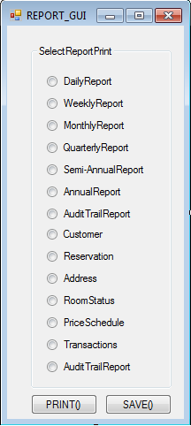

**Figure JJBB-03**

**Test Case ID**: JJBB-03

**Test Type**: Black Box

**Test Objective**: The objective of this test case is to provide a test for the Report UI module, to test this interface click on the REPORTS button on the main GUI , “Print()” and the “Save()” buttons. See Figure JJBB-03.

**Test Items**: Report sub-module

**Input Specifications**

1. Execute the JJBB Manager system.
2. Click on the right facing arrow in the top of the calendar page.
3. Click on the left facing arrow in the top of the calendar page.
4. Click on a date.
5. Click on an adjacent date.
6. Click on the “Reservation Report” button.
7. Click on the “Financial Report” button.
8. Click on the “Reset” button.
9. Click on the “Cancel” button.

**Output Specifications**

1. Monthly calendar is displayed correctly, with the month labeled at the top and the individual dates shown.
2. Monthly calendar is incremented by 1 month. The month label at the top is updated. The individual dates are updated.
3. Monthly calendar is decremented by 1 month. The month label at the top is updated. The individual dates are updated.
4. The single date is highlighted.
5. The range of all dates selected are highlighted.
6. The Reservation Report is now printed. This shows the reservation information for the range of dates selected.
7. The Financial Report is now printed. This shows the financial information for the range of dates selected.
8. The date selections are now deselected.
9. The JJBB system is terminated.

**Environmental Needs**

1. Computer system with JJBB system installed.
2. User input devices: Mouse.
3. Output devices: Printer.

**Special Procedural Requirements**: None

**Inter-case Dependencies**: None

**4.2 System Service Test Cases**

**Test Case ID**: JJBB-04

**Test Type**: White Box

**Test Objective**: The objective of this test case is to provide a test for the Verify Deposit System Service module. It is used to determine, if the customer has selected to make a deposit, if the deposit will go through or not.

**Test Items**: Verify Deposit sub-module

**Input Specifications**

1. Execute the JJBB Customer system.
2. Select a single vacant room on a single date.
3. Click on the "Confirm" button.
4. Enter valid user information for all fields.
5. Checkmark the "Deposit Yes" box.
6. Click on the "Confirm" button.

**Output Specifications**

1. returnStatus() will pass a boolean value depending on a successful or unsuccessful reservation.

**Environmental Needs**

1. Computer system with JJBB system installed.
2. User input devices: Mouse and Keyboard

**Special Procedural Requirements**: This test case can only be tested indirectly from the JJBB-02a test case. There is no interface which allows direct verification of the deposit, as it is coupled together with the Guest Information UI module.

**Inter-case Dependencies**: JJBB-01b and JJBB-02a

**Test Case ID**: JJBB-05

**Test Type**: White Box

**Test Objective**: The objective of this test case is to provide a test for the Format PDF System Service module. It is used to determine if the information gathered by this service correctly produces a report in PDF form.

**Test Items**: Format PDF sub-module

**Input Specifications**

1. Execute the JJBB Manager system.
2. Click on a date.
3. Click on the "Reservation Report" button.

**Output Specifications**

1. formatPDF() will pull the requested information from the databases.
2. The pdf class will be instantiated and populated.

**Environmental Needs**

1. Computer system with JJBB system installed.
2. User input devices: Mouse.

**Special Procedural Requirements**: This test case can only be tested indirectly from the JJBB-03 test case. There is no interface which allows direct PDF formatting, as it is coupled together with the Reports UI module and the Send-To-Manager service module.

**Inter-case Dependencies**: JJBB-03

**Test Case ID**: JJBB-06

**Test Type**: White Box

**Test Objective**: The objective of this test case is to provide a test for the Send-To-Manager System Service module. It is used to determine if the PDF passed from the Format PDF sub-module is correctly sent to the management.

**Test Items**: Send-To-Manager sub-module

**Input Specifications**

1. Execute the JJBB Manager system.
2. Click on a date.
3. Click on the "Reservation Report" button.

**Output Specifications**

1. sendToUI() will pass the instantiated PDF object created in the Format PDF sub-module.

**Environmental Needs**

1. Computer system with JJBB system installed.
2. User input devices: Mouse.

**Special Procedural Requirements**: This test case can only be tested indirectly from the JJBB-05 test case, which is also dependent on the JJBB-03 test case. These three modules are tightly coupled together to form a seamless service for the management.

**Inter-case Dependencies**: JJBB-03, JJBB-05

**Test Case ID**: JJBB-07

**Test Type**: White Box

**Test Objective**: The objective of this test case is to provide a test for the Check Hold-By-Date System Service module. It is used to determine if a no-guarantee reservation will actually drop according to the System Specification.

**Test Items**: Check Hold-By-Date sub-module

**Input Specifications**

1. Execute the JJBB Customer system.
2. Select a single vacant room on a single date.
3. Click on the "Confirm" button.
4. Enter valid user information for all fields.
5. Checkmark the "Deposit No" box.
6. Click on the "Confirm" button.
7. Click on the "Cancel" button to exit.
8. Change current date forward to the reservation date on computer system with JJBB system installed.
9. Execute the JJBB Manager system.
10. Click on the reservation date that the computer system was changed to.
11. Click on the "Reservation Report" button.

**Output Specifications**

1. checkReservations() will call the deleteThis() function of the evaluated reservation object.

**Environmental Needs**

1. Computer system with JJBB system installed.
2. User input devices: Mouse and Keyboard.

**Special Procedural Requirements**: This test case can only be tested indirectly from JJBB-02a test case and also by JJBB-03 test case, by creating a no-deposit reservation and waiting until the day of the reservation, then requesting a Reservation Report of that day. These sub-modules are tightly coupled in this test case. The System Specification states that a reservation with no deposit is held without guarantee up until a specified date. For this implementation of this requirement, the reservation is held until the day of the reservation, and if it is still has no deposit, will be dropped.

**Inter-case Dependencies**: JJBB-02a and JJBB-03

**Test Case ID**: JJBB-08

**Test Type**: White Box

**Test Objective**: The objective of this test case is to provide a test for the Calendar status System Service module. It is used to determine if a calendar status check correctly shows a monthly calendar with each date populated with the reservation statuses for each room on that date.

**Test Items**: Calendar Status sub-module

**Input Specifications**

1. Execute the JJBB Customer system.

**Output Specifications**

1. sendCalendar() function will send the reservation date data to the UI.
2. The calendar[] array is the data that is passed to the Reservation Calendar UI module.

**Environmental Needs**

1. Computer system with JJBB system installed.
2. User input devices: Mouse.

**Special Procedural Requirements**: This test case can only be tested indirectly from JJBB-01a or JJBB-01b test cases. Upon execution of the program, the Reservation Calendar UI module will automatically call the Calendar Status System Service module.

**Inter-case Dependencies**: JJBB-01a or JJBB-01b

**4.3 Domain Object Test Cases**

**Test Case ID**: JJBB-09 through JJBB-11

**Test Type**: White Box

**Test Objective**: The objective of this test case is to provide a test for the Customer Creation, Reservation Creation, and Account Creation Domain Object modules. This is to simply verify that on reservation creation, the customer, reservation and account objects are properly instantiated and stored in the database.

**Test Items**: Customer Creation sub-module, Reservation Creation sub-module, Account Creation sub-module

**Input Specifications**

1. Execute the JJBB Customer system.
2. Select a single vacant room on a single date.
3. Click on the "Confirm" button.
4. Enter valid user information for all fields.
5. Checkmark the "Deposit Yes" box.
6. Click on the "Confirm" button.

**Output Specifications**

JJBB-09

1. getCustomerNo() called on that customer instance will return a valid customer number.

JJBB-10

1. getReservationNo() called on that customer instance will return a valid reservation number.

JJBB-11

1. getAccountNo() called on that customer instance will return a valid account number.

**Environmental Needs**

1. Computer system with JJBB system installed.
2. User input devices: Mouse and Keyboard.

**Special Procedural Requirements**: This test case can only be tested indirectly from JJBB-02a test case. There is no interface which allows direct verification of these classes being instantiated.

**Inter-case Dependencies**: JJBB-01b and JJBB-02a

**Test Case ID**: JJBB-12 and JJBB-13

**Test Type**: White Box

**Test Objective**: The objective of this test case is to provide a test for the Reservation Report and Financial Report Domain Object modules. This is to simply verify that on Report Request, reservation and financial report objects are properly instantiated.

**Test Items**: Reservation Report sub-module, Financial Report sub-module

**Input Specifications**

1. Execute the JJBB Manager system.
2. Click on a date.
3. Click on the “Reservation Report” button.
4. Click on the “Financial Report” button.

**Output Specifications**

1. sendToUI() from the Send-To-Manager System Service module will pass the instantiated PDF object created in the Format PDF System Service module to the Report UI module.
   * This will be true for both Reservation Report and the Financial Report, test cases JJBB-12 and JJBB-13 respectively.

**Environmental Needs**

1. Computer system with JJBB system installed.
2. User input devices: Mouse.

**Special Procedural Requirements**: This test case can only be tested indirectly from the JJBB-03 test case. There is no interface which allows direct verification of the reservation and financial report classes being instantiated.

**Inter-case Dependencies**: JJBB-03, JJBB-05 and JJBB-06